**Marki Sveen**

**Feature 1: Volunteer Opportunities**

*Narrative description*

The ‘Volunteer Opportunities’ feature is an efficient way for the hospital to post volunteer opportunities and receive volunteer applications. Visitors to the website will see a special section dedicated to ‘Volunteer Opportunities’ on the homepage. By clicking on a link in this section or the link in the navigation menu under ‘Support Us’ the visitor will be taken to the ‘Volunteer Opportunities’ page. Your Volunteer Coordinator will be able to easily update opportunities, as well as track, organize and process applications. From the perspective of a potential volunteer the simplicity of this service will decrease the amount of steps they would need to take to apply.

The ‘Volunteer Opportunities’ feature will have an administrative page that will allow the Volunteer Coordinator to keep track of applications and post new opportunities.

The databases will look like this:

Available opportunities:

|  |  |
| --- | --- |
| Opportunity ID | Unique Identifier (PK) |
| Opportunity Title | Text up to 100 characters |
| Department | Text up to 100 characters |
| Skills Experience | Text up to 400 characters |
| Benefits Recognition | Text up to 400 characters |
| Other Requirements | Text up to 100 characters |
| Time Commitment | Text up to 40 characters |
| Date and Time | Text up to 40 characters |
| Contact Person | Text up to 40 characters |

Application form:

|  |  |
| --- | --- |
| Submission ID | Unique Identifier (PK) |
| Opportunity ID | Unique Identifier (FK) |
| First Name | Text up to 40 characters |
| Last Name | Text up to 40 characters |
| Address | Text up to 100 characters |
| Phone | Text up to 12 characters |
| Email | Text up to 40 characters |
| Date of Birth | Date |
| Occupation | Text up to 40 characters |
| Previous Experience | Text up to 400 characters |
| Why BRDHC | Text up to 100 characters |
| Commitment Length | Text up to 10 characters |
| Day | Text up to 10 characters |
| Start Time | Text up to 10 characters |
| End Time | Text up to 10 characters |
| Reviewed | Yes or No |

*Dataflow Models*

Here is how the “Apply to Volunteer at BRDHC” dataflow model would look:

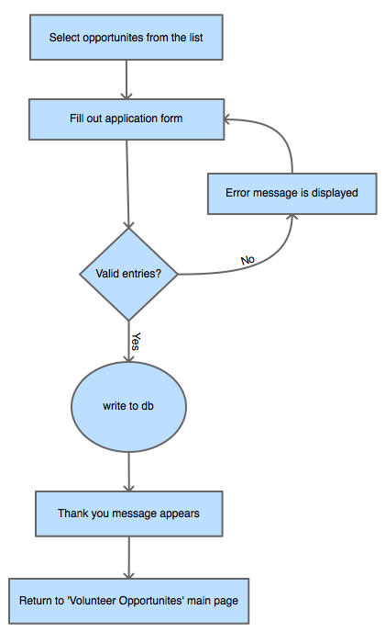

Here is how an administrator would add an opportunity:

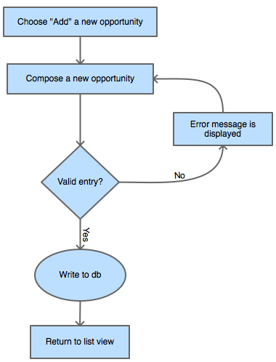

Here is how an administrator would edit an opportunity:

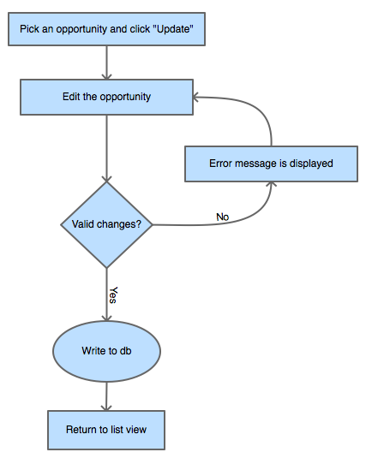

Here is how an administrator would delete an opportunity:

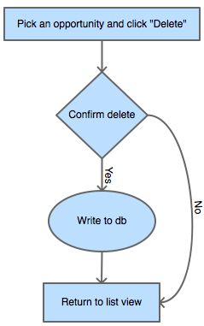

Here is how an administrator would review a submission:

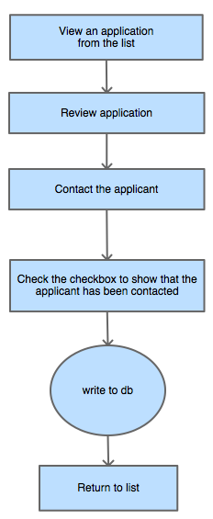

*Wireframes*

Here is how the “Apply to Volunteer at BRDHC” wireframe would look:

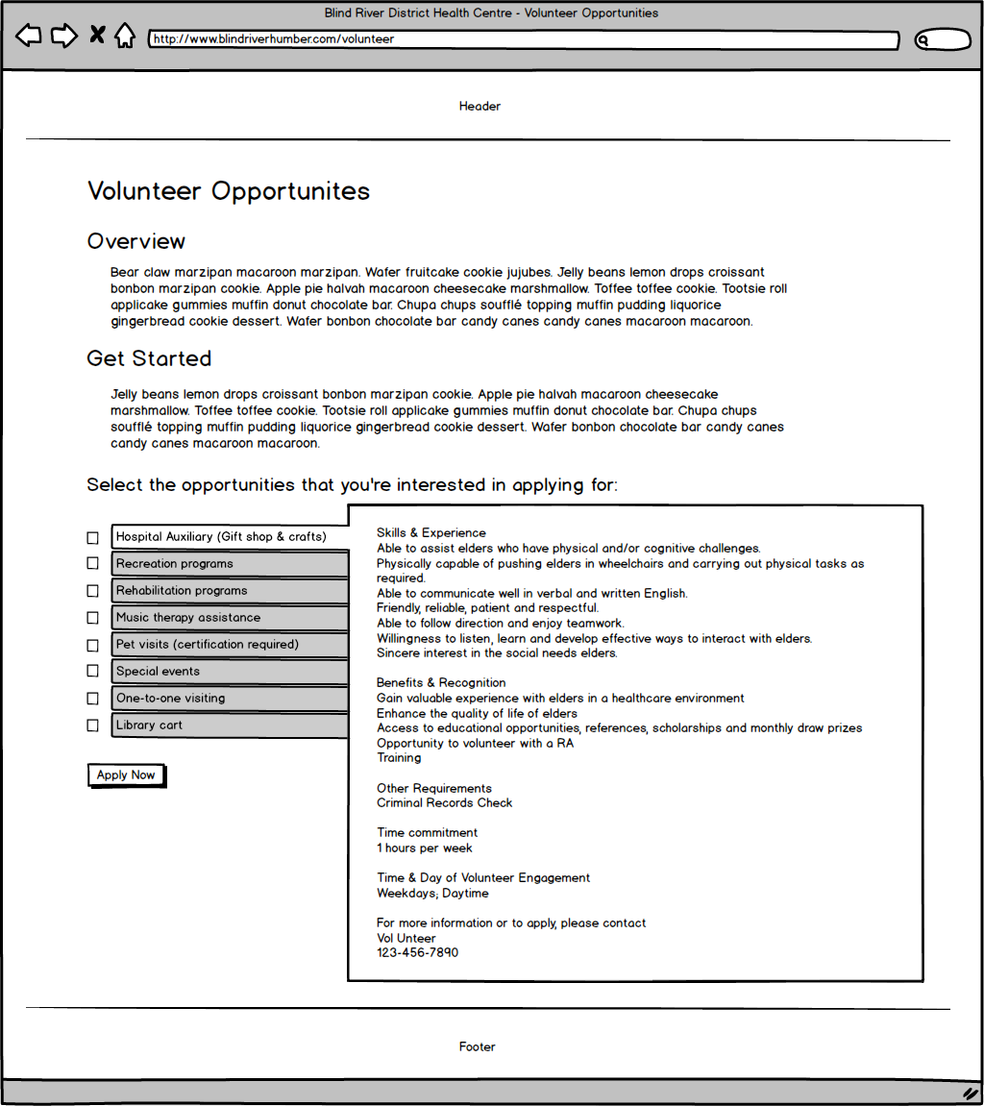

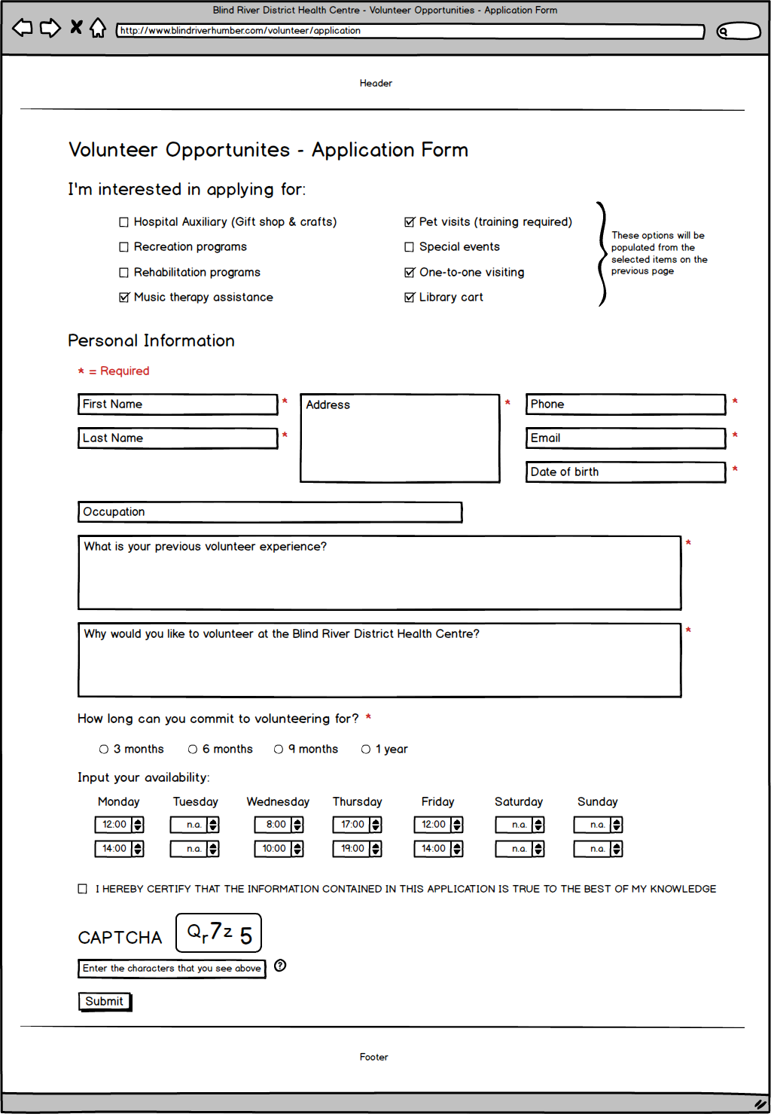

Here is how an administrator would post a submission:

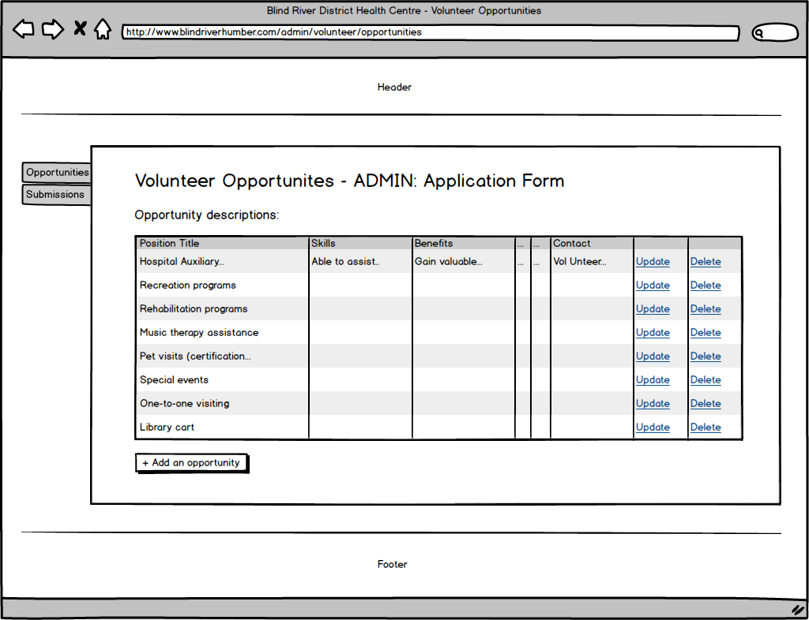

Here is how an administrator would process an application:

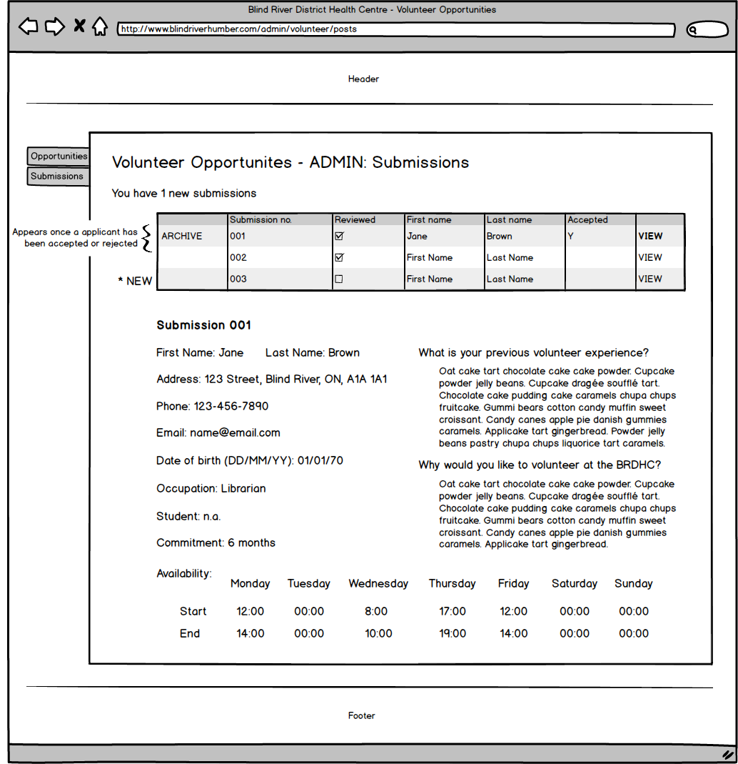

**Feature 2: Gift Shop**

*Narrative description*

The ‘Gift Shop’ feature includes two sub-features: a free service, ‘Send a handwritten card to a loved one’ and a paid service, ‘Send flowers to a loved one’. Visitors to the website will see a special section dedicated to the gift shop on the homepage. By clicking on a link in this section or by clicking the link in the navigation menu under ‘Patients & Visitors’ it will take them to the gift shop page. This service allows friends and family to express their love and sympathy in a special way if they cannot be there in person. With the generous support of the hospital auxiliary volunteers, patients and their loved ones will feel the extra effort the hospital provides to help them feel loved and supported.

The ‘Gift Shop’ feature will have an administrative page that will allow the gift shop volunteers to keep track of the orders. The orders will fall under two categories: ‘Send a card’ or ‘Send flowers’. The volunteer will be able to keep track of which orders have been completed, and if the sender has been notified upon delivery. The volunteer will be able to archive previous orders once they have been fulfilled.

The databases will look like this:

Sending cards and flowers:

|  |  |
| --- | --- |
| Card_Id | Unique Identifier (PK) |
| Sender’s name | Text up to 40 characters |
| Sender’s email | Text up to 40 characters |
| Patient name | Text up to 40 characters |
| Patient room number | Text 4 characters |
| To | Text up to 40 characters |
| From | Text up to 40 characters |
| Message | Text up to 400 characters |

|  |  |
| --- | --- |
| Bouquet number | Numeric |
| Bouquet price | Numeric, decimal |
| Bouquet image | Text up to 100 characters |
| Payment total | Numeric, decimal |
| Date | Date |
| Written | True or False |
| Delivered | True or False |
| Sender notified | True or False |
| Archived | True or False |

Billing and Payment Information will be stored by a third party (PayPal)

*Dataflow Models*

Here is how the “Send a card to a loved one” dataflow model would look:

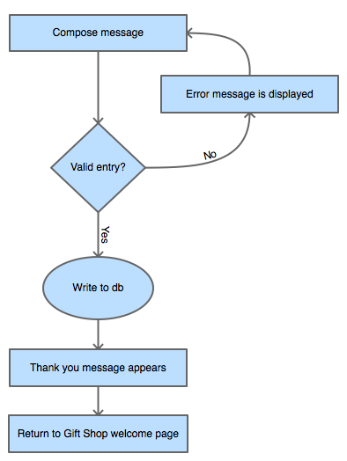

Here is how the “Send flowers to a loved one” dataflow model would look:

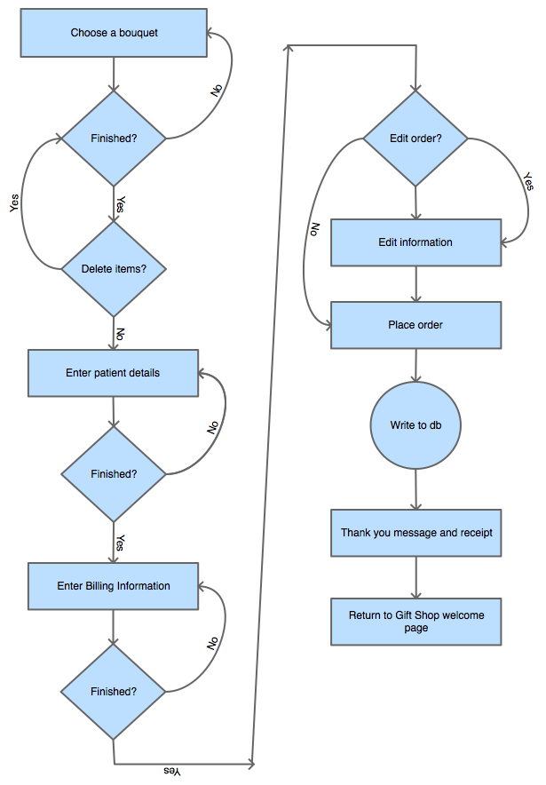

Here is how an administrator would process orders:

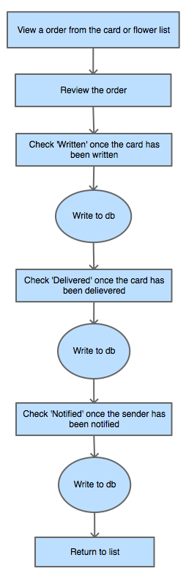

Here is how an administrator would add bouquets from the storefront:

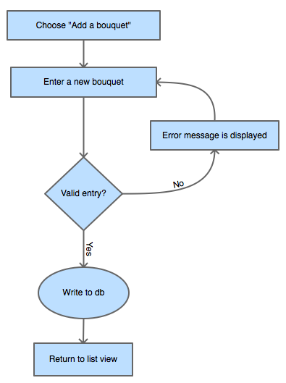

Here is how an administrator would remove bouquets from the storefront:

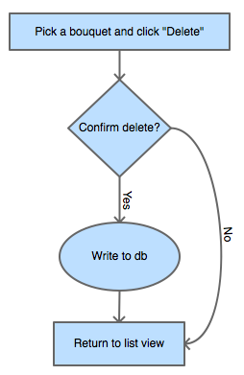

Here is how an administrator would edit bouquets in the storefront:

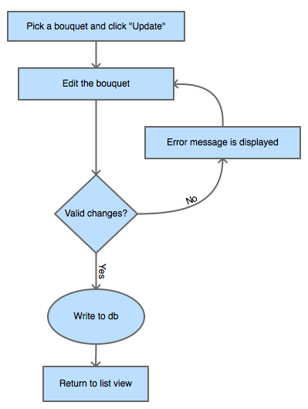

*Wireframes*

Here are the wireframes for the Gift Shop:

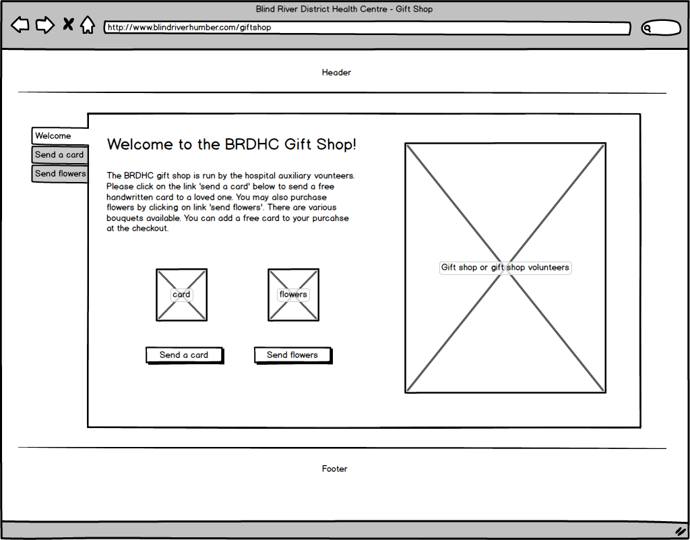

Here is the wireframe for ‘Send a card to a loved one’:

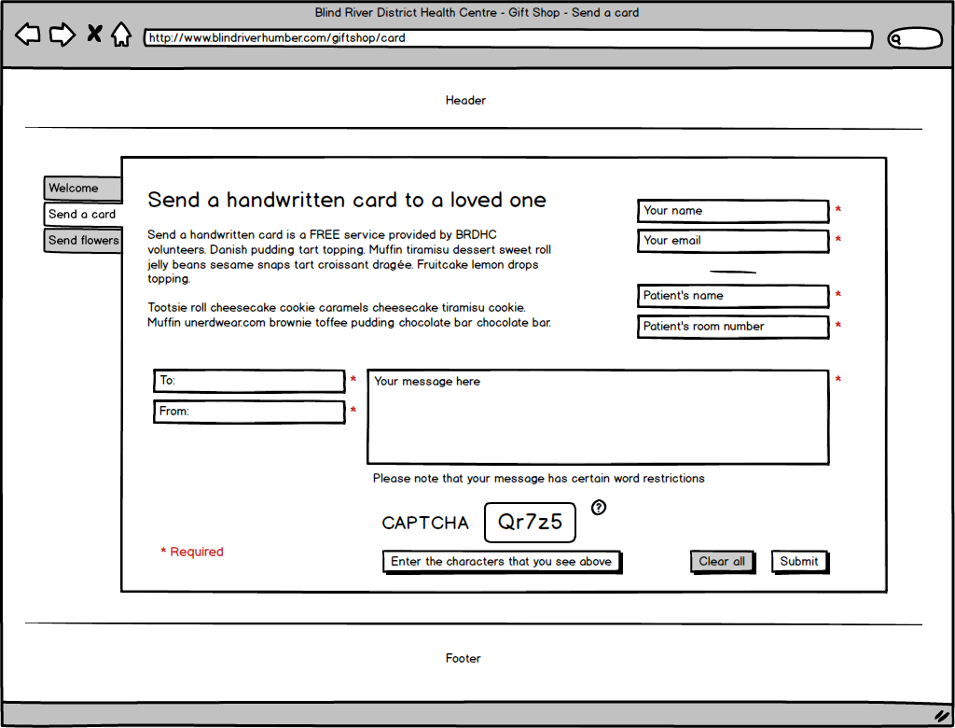

Here are the wireframes for ‘Send flowers to a loved one’:

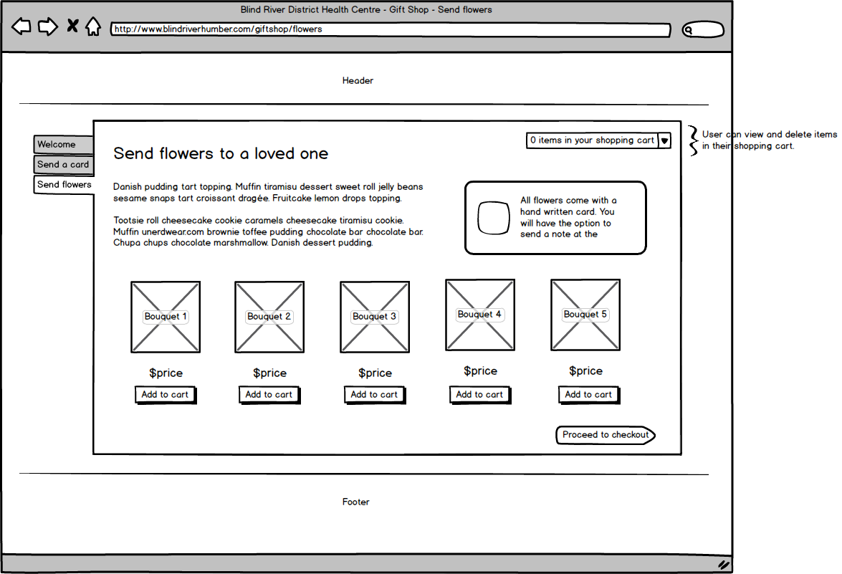

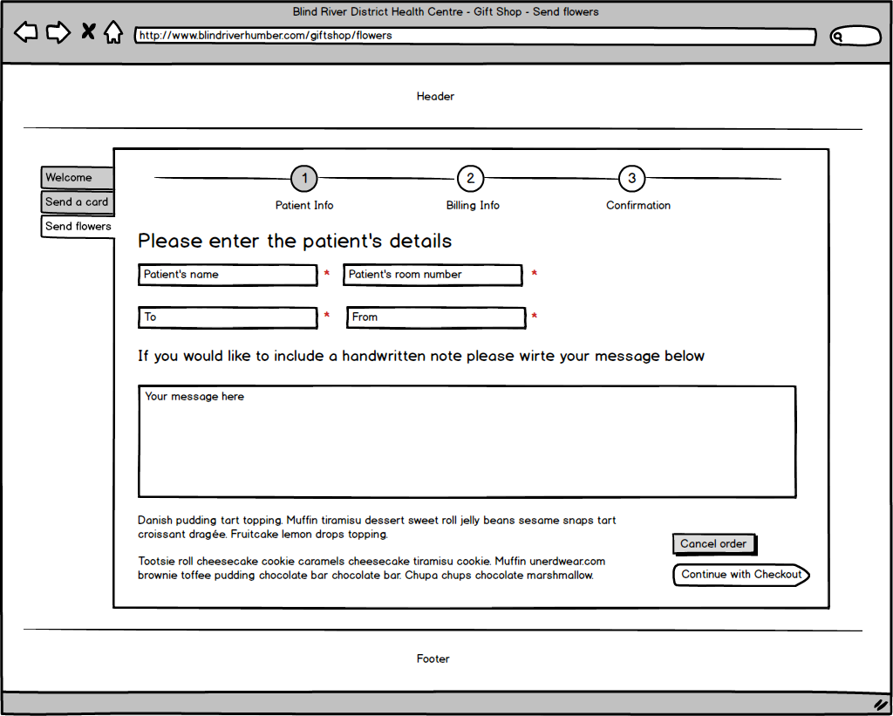

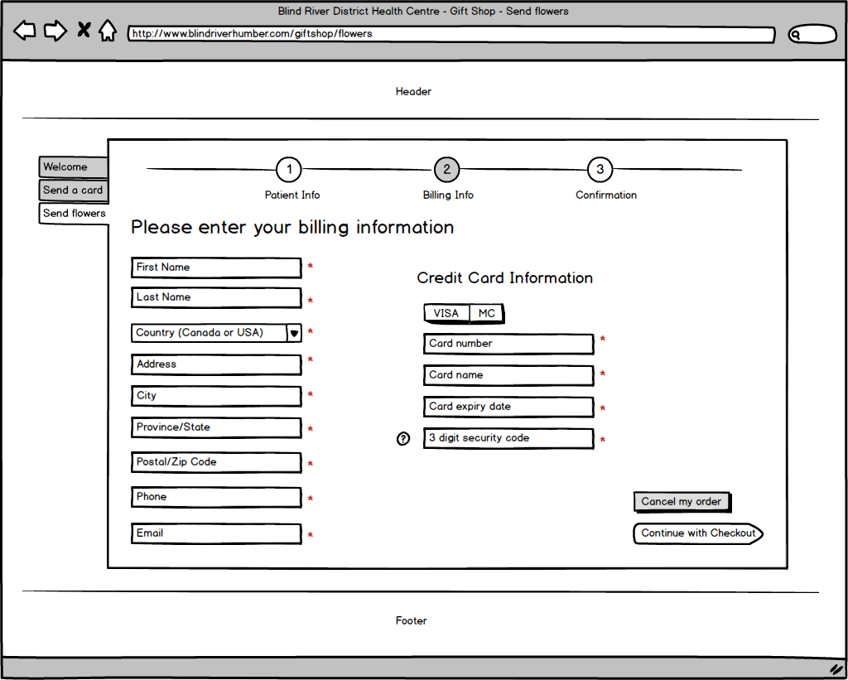

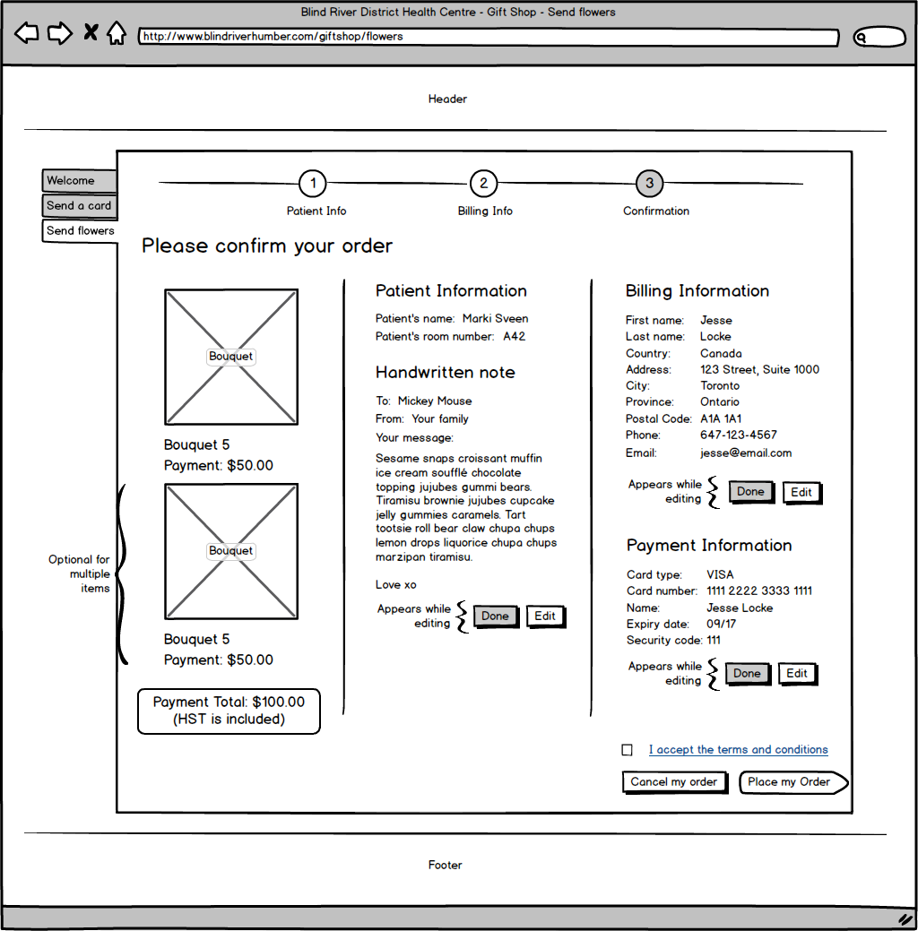

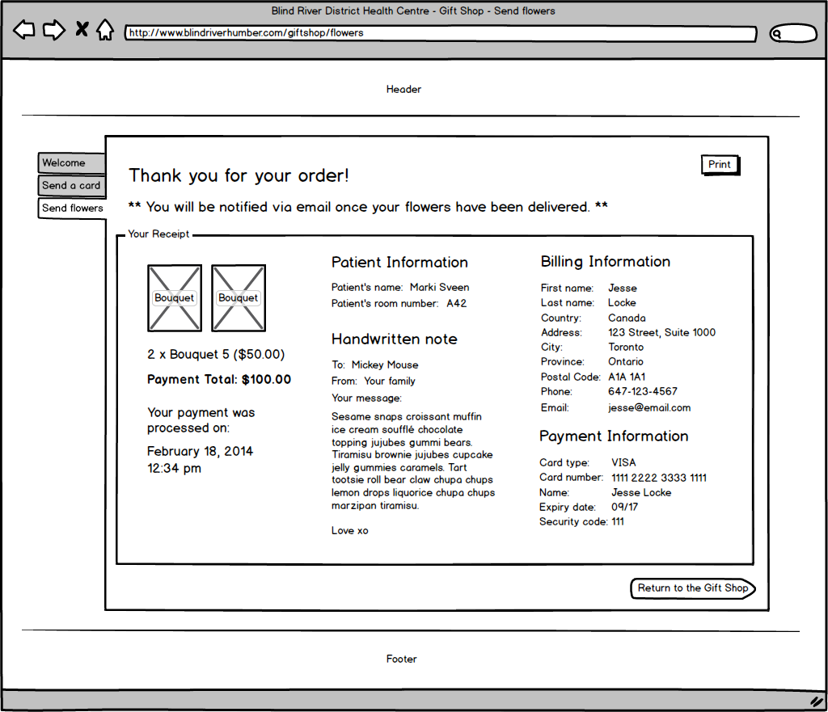

Here is the wireframe for an administrator to process orders:

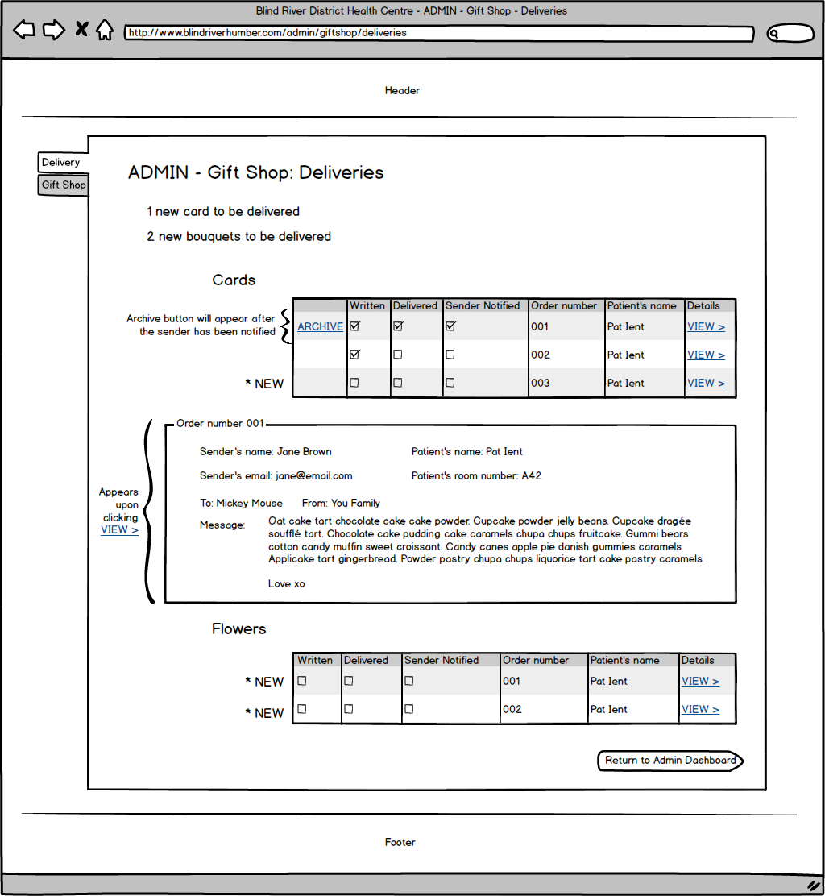

Here is the wireframe for an administrator to add or remove bouquets from the storefront:

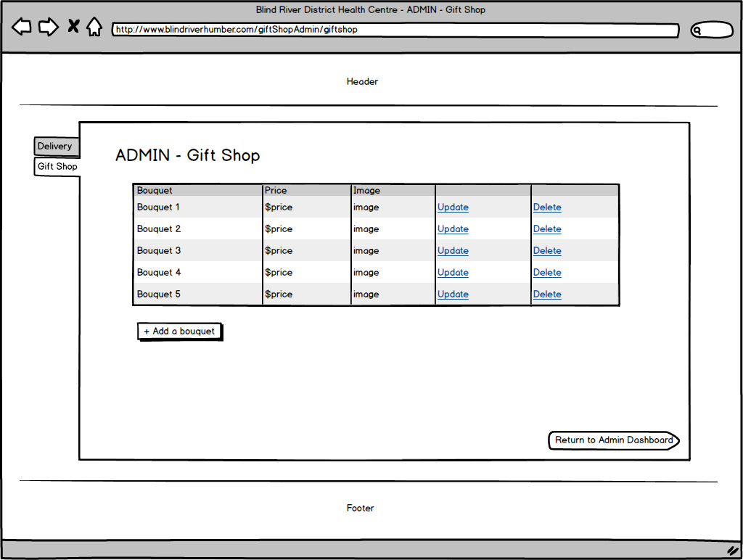

**Feature 3: Health Tools**

*Narrative description*

The ‘Health Tools’ feature includes two sub-features: a ‘Healthy Eating Quiz’ and a ‘Smoking Cost Savings Calculator’. Visitors to the website can visit the ‘Health Tools’ page by clicking the link in the navigation menu under ‘Resources’. This service allows visitors to learn about healthy choices in a modern way.

The ‘Health Tools’ feature will have an administrative page for each sub-feature. For the ‘Healthy Eating Quiz’ the administrator will be able to add, remove or modify question-answer pairs in the quiz. For the ‘Smoking Cost Savings Calculator’ the administrator can modify the text for the various “What you can do with (a certain amount of money saved)” and “Health benefits within (a certain time frame) after you quit”.

The databases will look like this:

|  |  |
| --- | --- |
| Question_Id | Unique Identifier (PK) |
| THIS name | Text up to 20 characters |
| THIS image | Link |
| THIS calories | Numeric |
| THIS fat | Numeric |
| THAT name | Text up to 20 characters |
| THAT image | Link |
| THAT calories | Numeric |
| THAT fat | Numeric |
| Answer | Text up to 20 characters |

*Dataflow Models*

Here is how the “Health Tools: Healthy Eating Quiz” dataflow model would look:

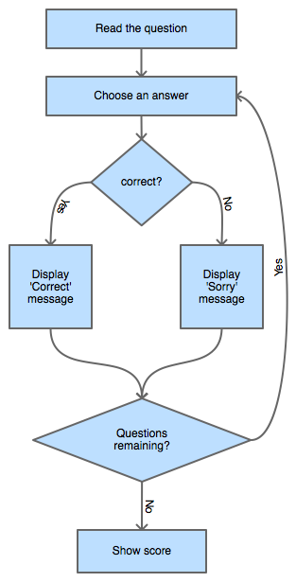

Here is how the “Health Tools: Smoking Cost Calculator” dataflow model would look:

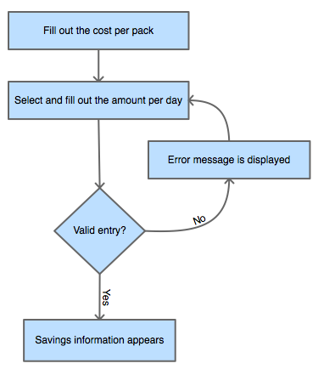

Here is how an administrator would add a question to the quiz:

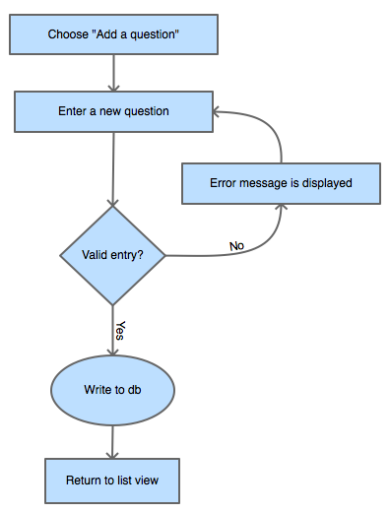

Here is how an administrator would remove a question from the quiz:

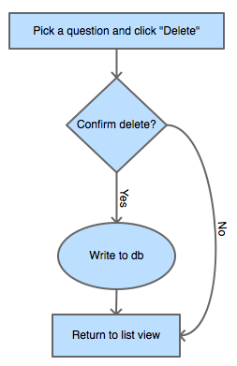

Here is how an administrator would edit a question in the quiz:

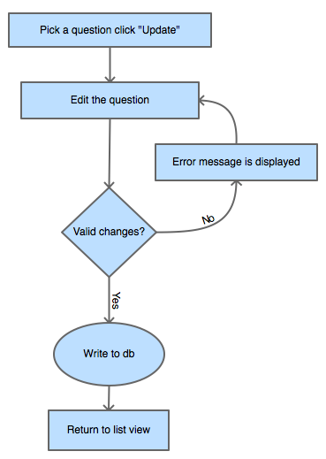

Here is how an administrator would edit cost savings information:

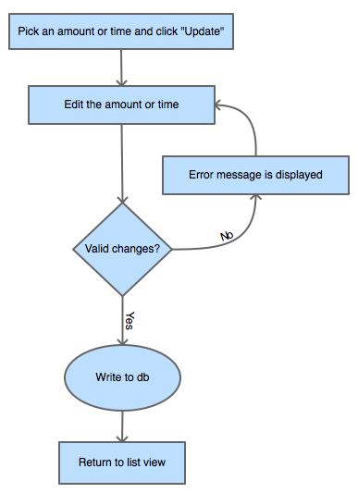

*Wireframes*

Here is how the “Health Tools: Healthy Eating Quiz” wireframes would look:

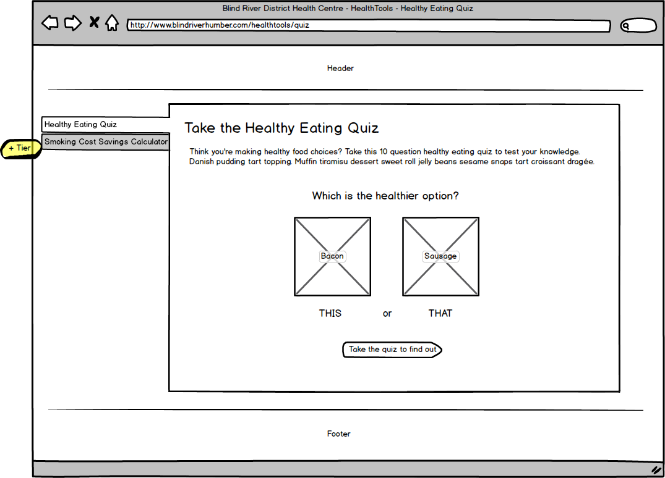

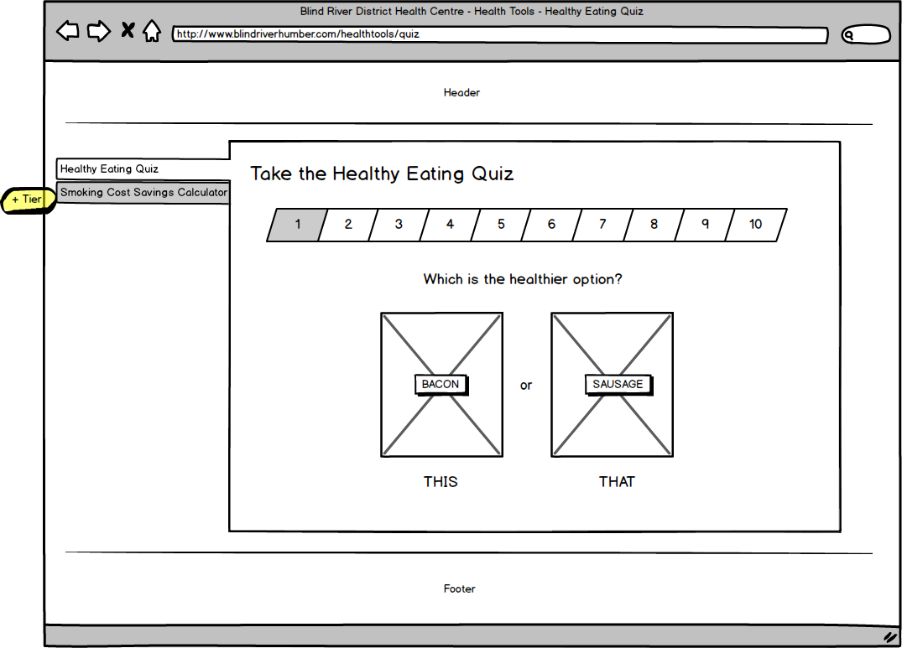

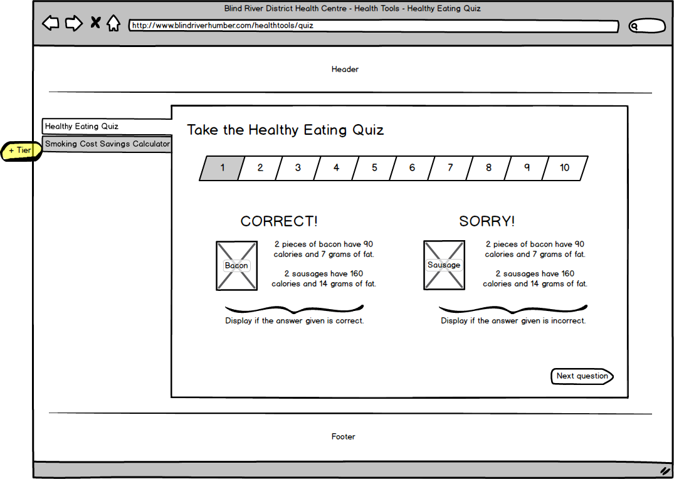

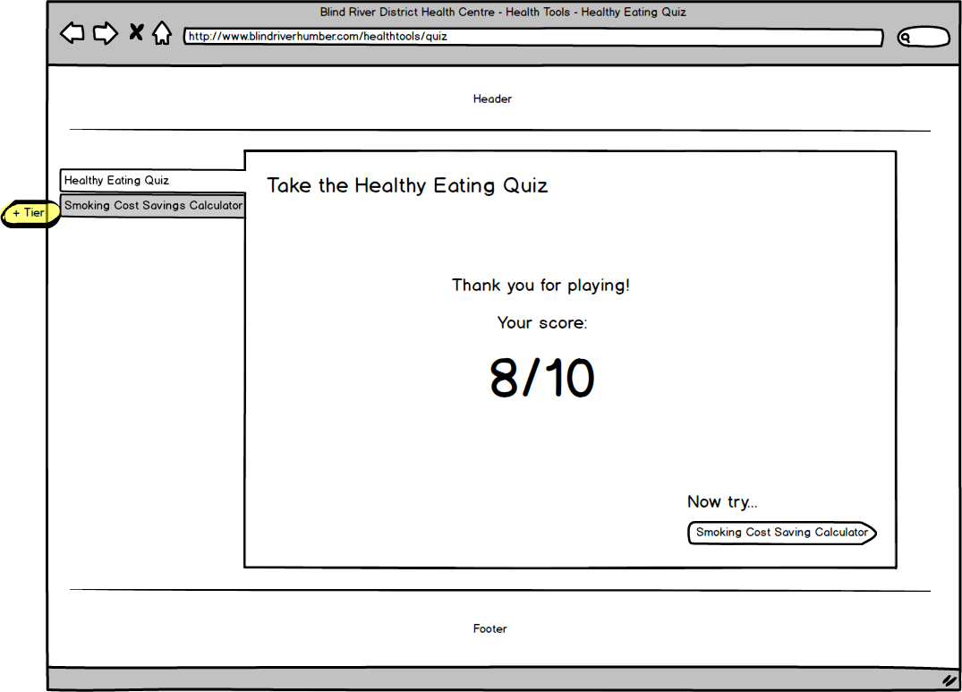

Here is how the “Health Tools: Smoking Cost Calculator” wireframes would look:

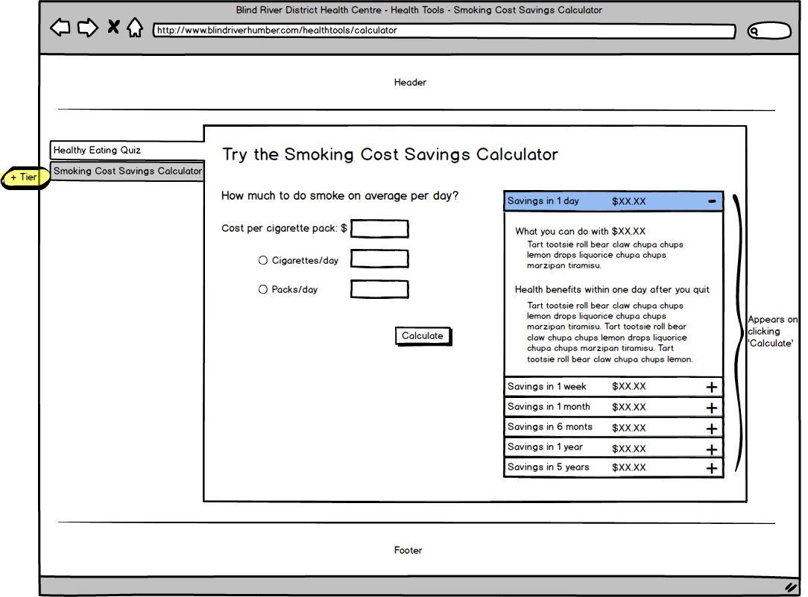

Here is how an administrator modifying the quiz would look:

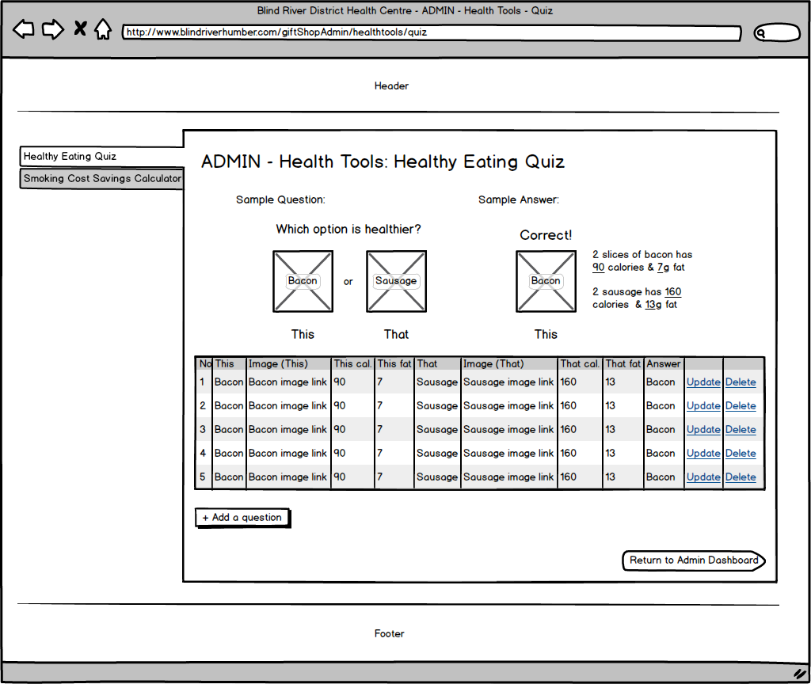

Here is how an administrator modifying the calculator would look:

